AWS Clound Formation:

Cloud formation is a sevice which provide the readymade template it is used aws services like launching ec2-instance, creating s3 bucket

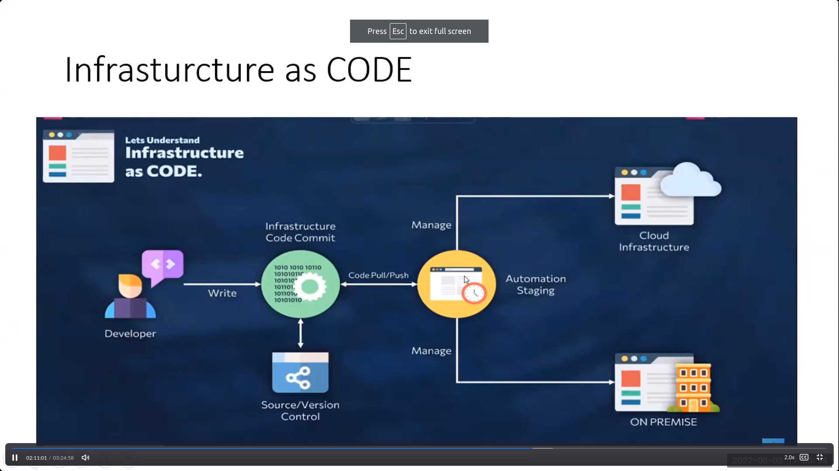

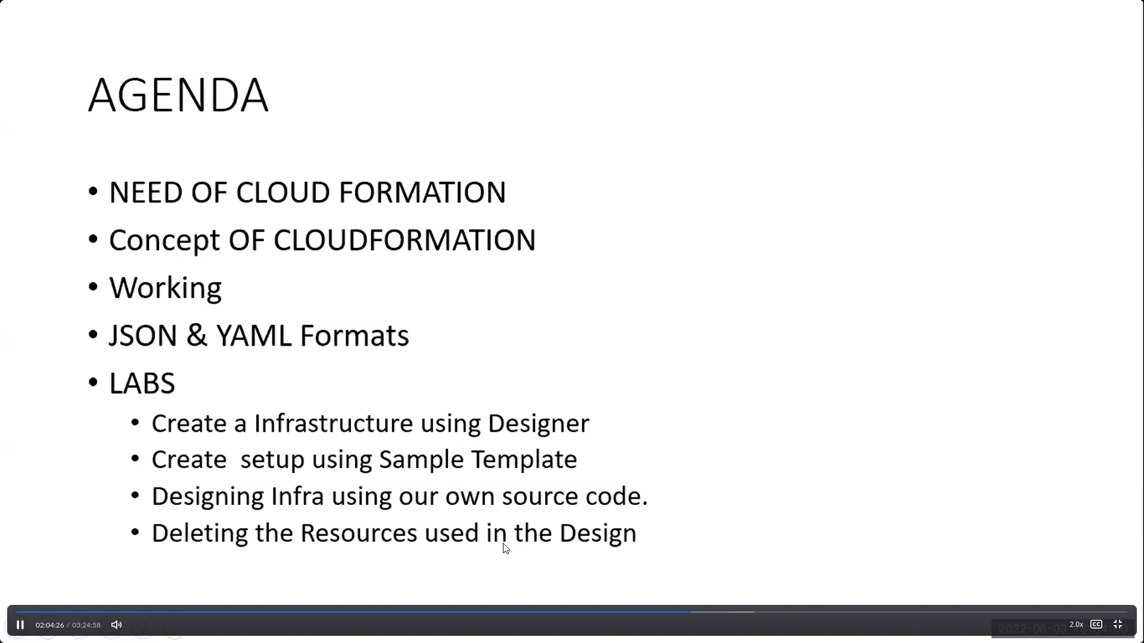

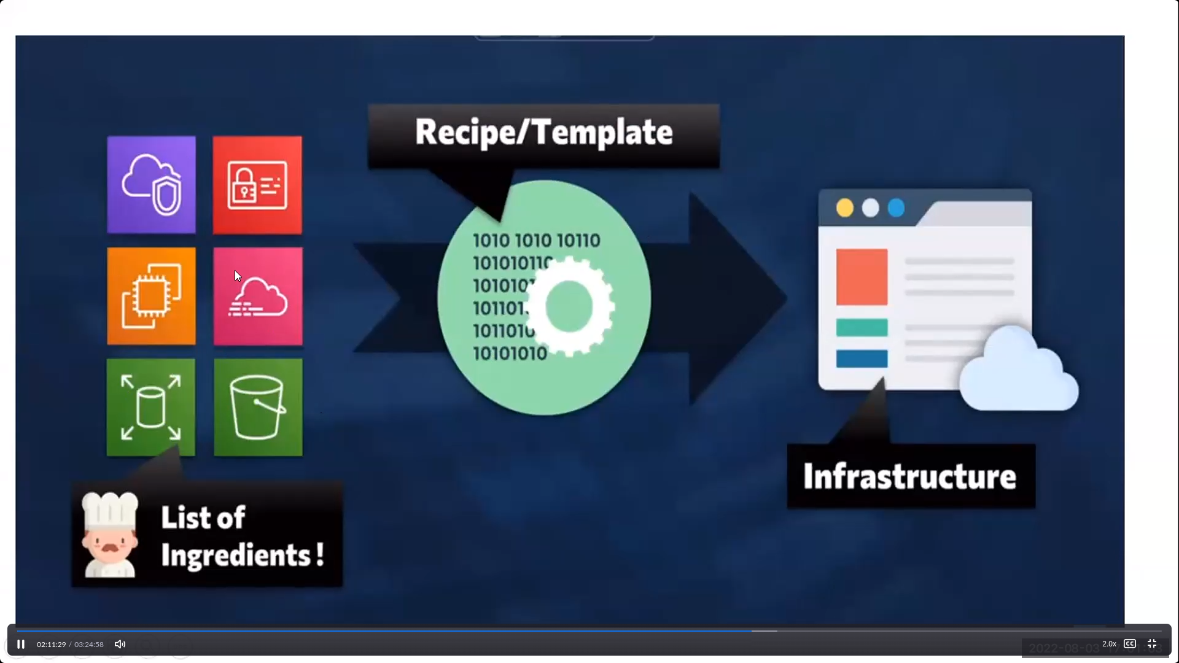

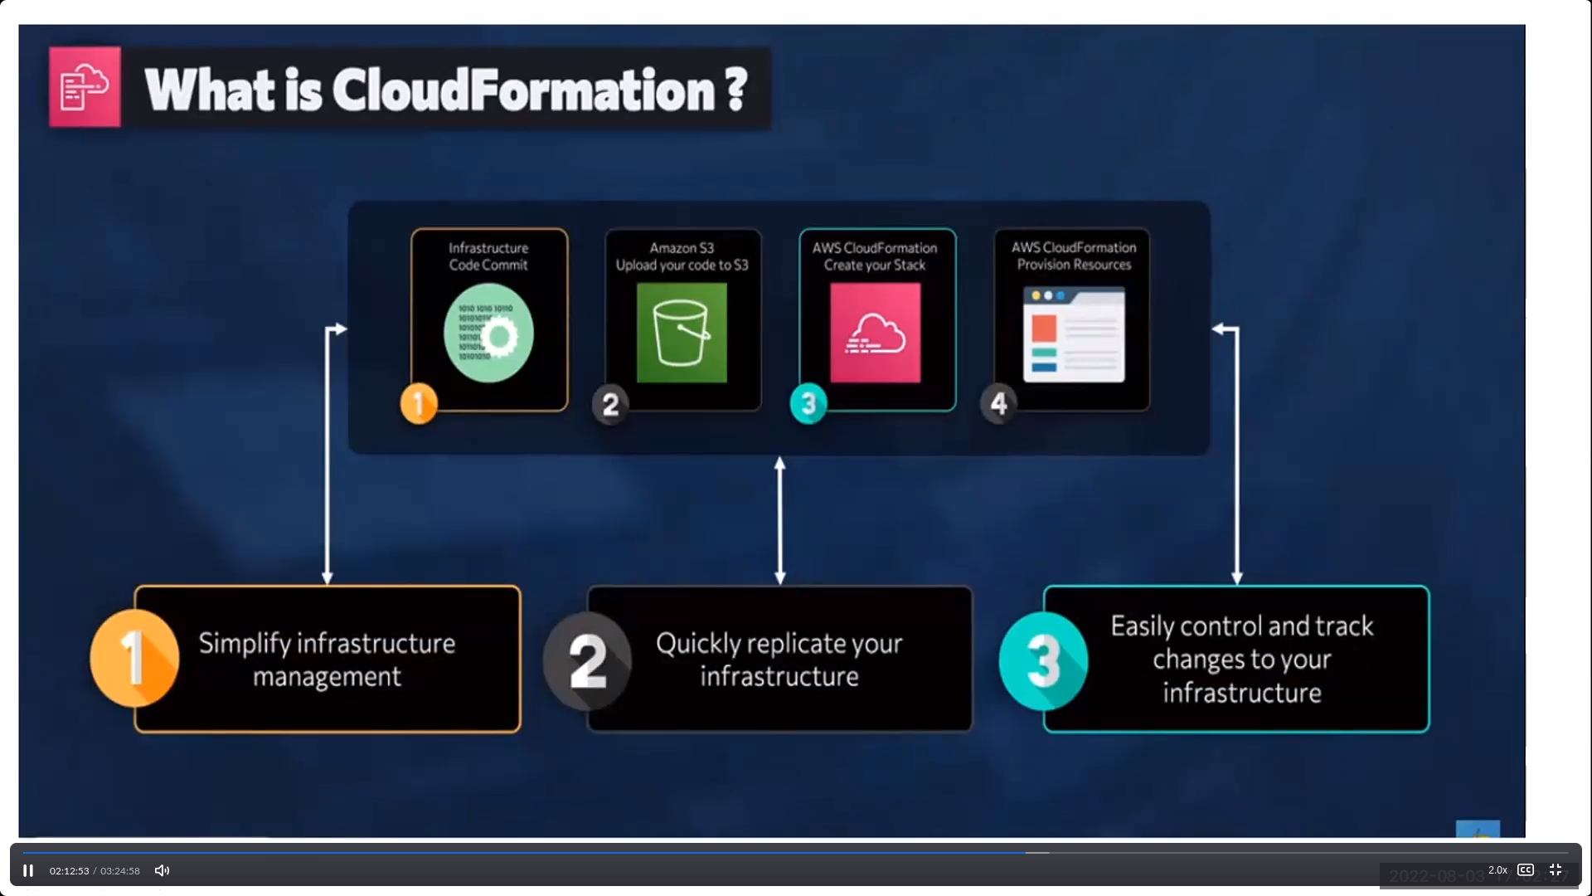

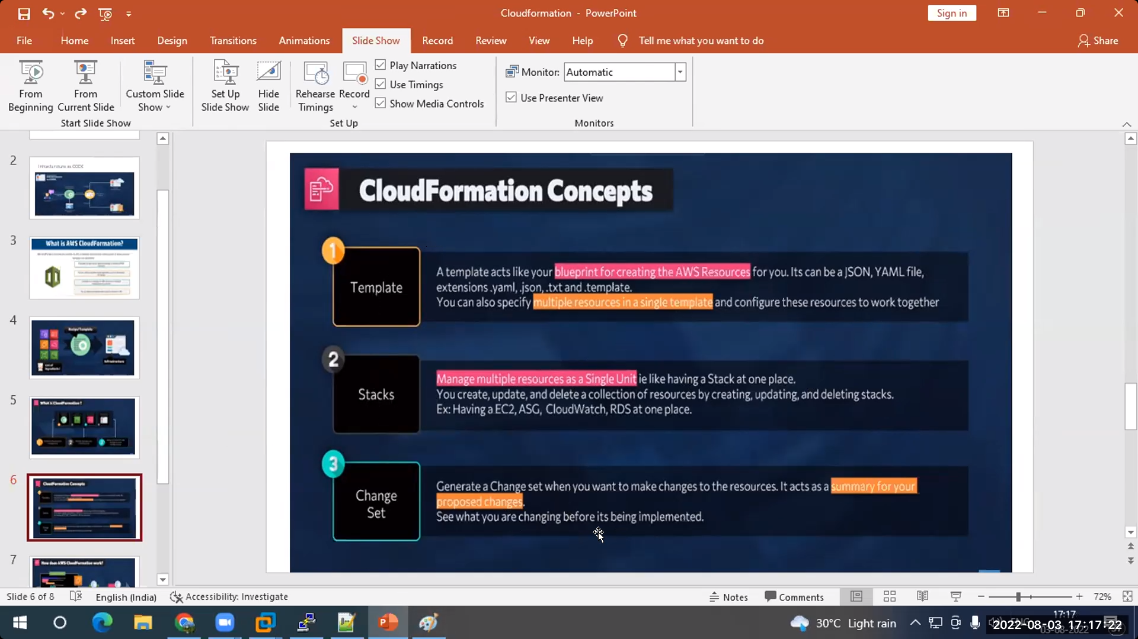

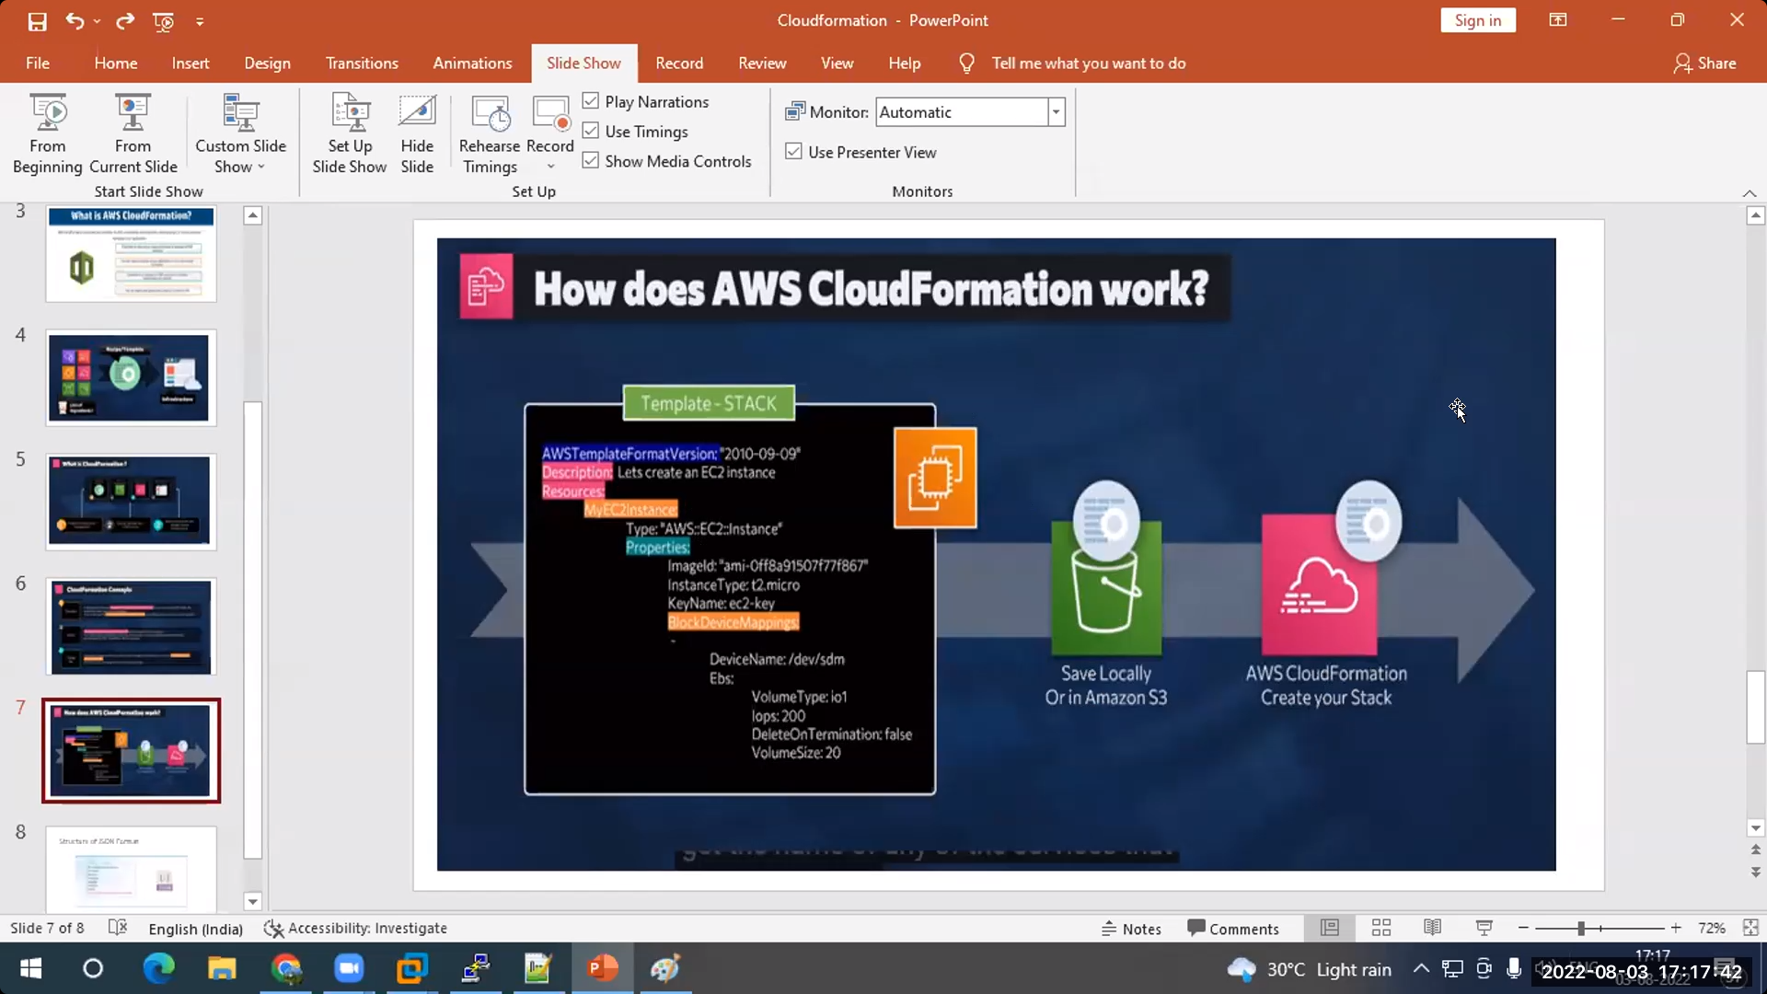

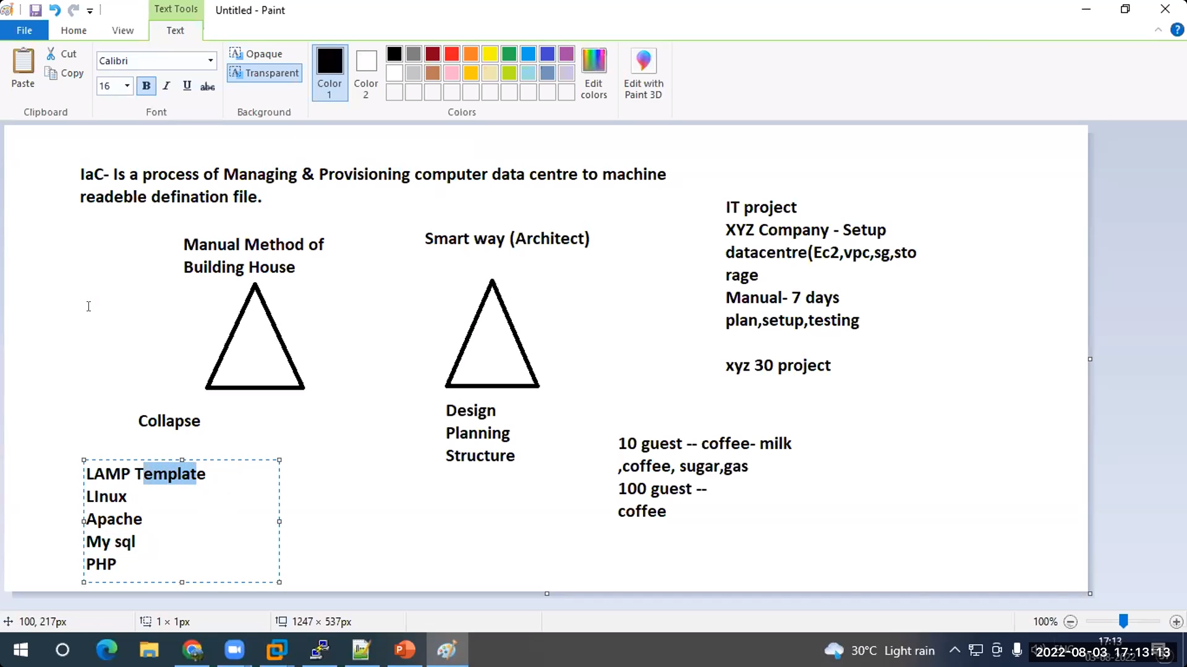

Three types of cloud formation steps:

Method-1(s3 bucket creation):

Step-1: search for cloud formation and click create stack

Step-2: select “create template for designer”

Step3: after step-2 “create template for designer” displayes and click on it

Step4: Drag any resource type (s3 bucket)

Step4: click on create stack which is like cloud symbol which is above the Resourc Type

Step5: click on next and write stack name and click on next

Method-2(lamp creation)

Step-1: search for cloud formation and click create stack

step2: select “use a sample template”

step3: select “ lamstack” from sample templates

step4:enter the details-: stackname,Dbname,Dbpasswor,Dbrootpassword,Dbuser,instancetype[t2.micro]

,keypair

step5: click on next,next,create stack

Method3(s3bucket with own file)

Step-1: search for cloud formation and click create stack

step2: select “template is ready” and after that select upload template and after that click on choose file

repeat same as method1 from step-3